EXPERIMENT : 04

NAME : HARISARAN.A ROLL NO : 240701170

Aim:
To design and implement a simple Login Screen for a mobile application where users can enter their email and password to sign in.
Tools/Technology Used:
- Android Studio / Flutter / Any UI design tool
- Programming language: Java / Kotlin / Dart
- Emulator or Mobile device

Procedure:
- Open the development tool (Android Studio / Flutter).
- Create a new mobile application project.
- Design the login interface using UI components.
- Add a Text field for Email input.
- Add a Password field with hidden characters for security.
- Create a Sign in button for user login action.
- Apply styles such as background color, rounded input fields, and centered layout.
- Run the application on an emulator or mobile device to test the login screen.

Description of the Screen:
The login screen contains:
- A title “Login” at the center.
- An Email input field where the user enters their email (example: hari@gmail.com).
- A Password field where characters are hidden using asterisks for security.
- A Sign in button that allows the user to log into the application.

Result:
The login screen was successfully designed and allows users to enter their email and password to access the application.

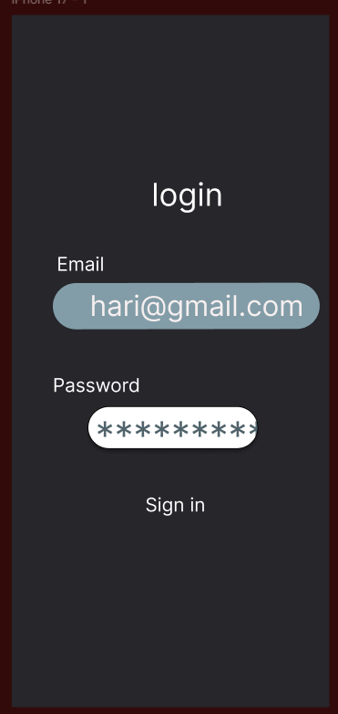

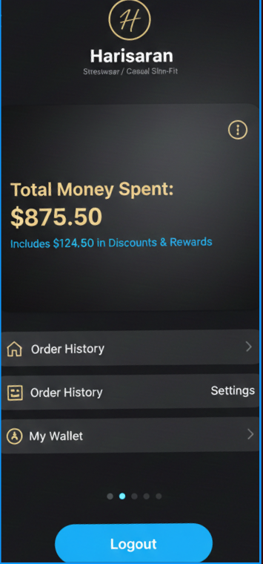

LINK:
https://www.figma.com/design/taZZkXhq60KEVzjyLP6bfN/Untitled?node-id=0-1&t=4S0DvMcLKQqBZ8wo-1

